Week 1: VPN Concepts and Configuration
Week1 FortiGate_SSL-VPN_Config

1. Introduction
A Virtual Private Network (VPN) provides secure, encrypted communication over public networks such as the Internet. Organizations use VPN technologies to protect data, enable remote access, and connect multiple sites securely.
As part of Week 1 of this project, the main focus is to study VPN types and implement an SSL VPN Remote Access solution on FortiGate.

2. VPN Overview
VPNs fall into two major categories depending on their purpose and connection type.

2.1 Site-to-Site VPN
A Site-to-Site VPN securely connects two separate networks, such as a branch office and headquarters.
- Typically implemented using IPsec.
- Used for permanent, always-on tunnels.
- Ensures private communication between networks over the internet.

2.2 Remote Access VPN
Allows individual users (employees, administrators, students, etc.) to connect securely to an internal network from outside.
There are two main types:

a. SSL VPN
- Operates over HTTPS (TCP 443)
- Uses SSL/TLS encryption
- Works through a browser or FortiClient
- Easy to deploy behind NAT and firewalls
- Ideal for remote workers

b. IPsec Remote Access
- Uses IPsec protocols
- Requires a VPN client
- Best for corporate-managed devices
In this project, we focus on SSL VPN (Tunnel Mode).

3. Why SSL VPN?
SSL VPN is chosen in Week 1 because:
- It works on port 443, which is rarely blocked.
- It doesn’t require a special tunnel protocol.
- It provides secure access to LAN resources for remote users.
- It supports user authentication, address assignment, and policy-based access.
SSL VPN (Tunnel Mode) assigns a virtual IP to the remote user so they can securely route inside the internal network.

4. Network Design (Week 1)
The lab environment for Week 1 uses the following setup:
Laptop → Home Router → VMware → FortiGate VM
- WAN (port1): Receives DHCP IP from home router
- LAN (port2): Static IP 192.168.100.1/24
- SSL-VPN Address Pool: 10.212.134.200 – 10.212.134.210
- Access: FortiGate Web GUI

5. Week 1 Scope
The following tasks are included in Week 1:
- Configure WAN and LAN interfaces
- Create Local User for VPN authentication
- Create User Group for SSL VPN users
- Configure SSL-VPN Settings
- Configure SSL-VPN Portal (Tunnel Mode)
- Assign Tunnel Address Pool
- Create Firewall Policies for VPN traffic
- Document all steps with screenshots

6. Summary
Week 1 focuses on understanding VPN concepts and implementing the complete SSL VPN remote access configuration on FortiGate.
All components (interfaces, users, portal, address pool, and policies) are prepared for testing in the upcoming project weeks.

7. Configuration Steps

Figure 1 – FortiGate Dashboard

Shows the main system summary, firmware version, uptime, and status of all interfaces.
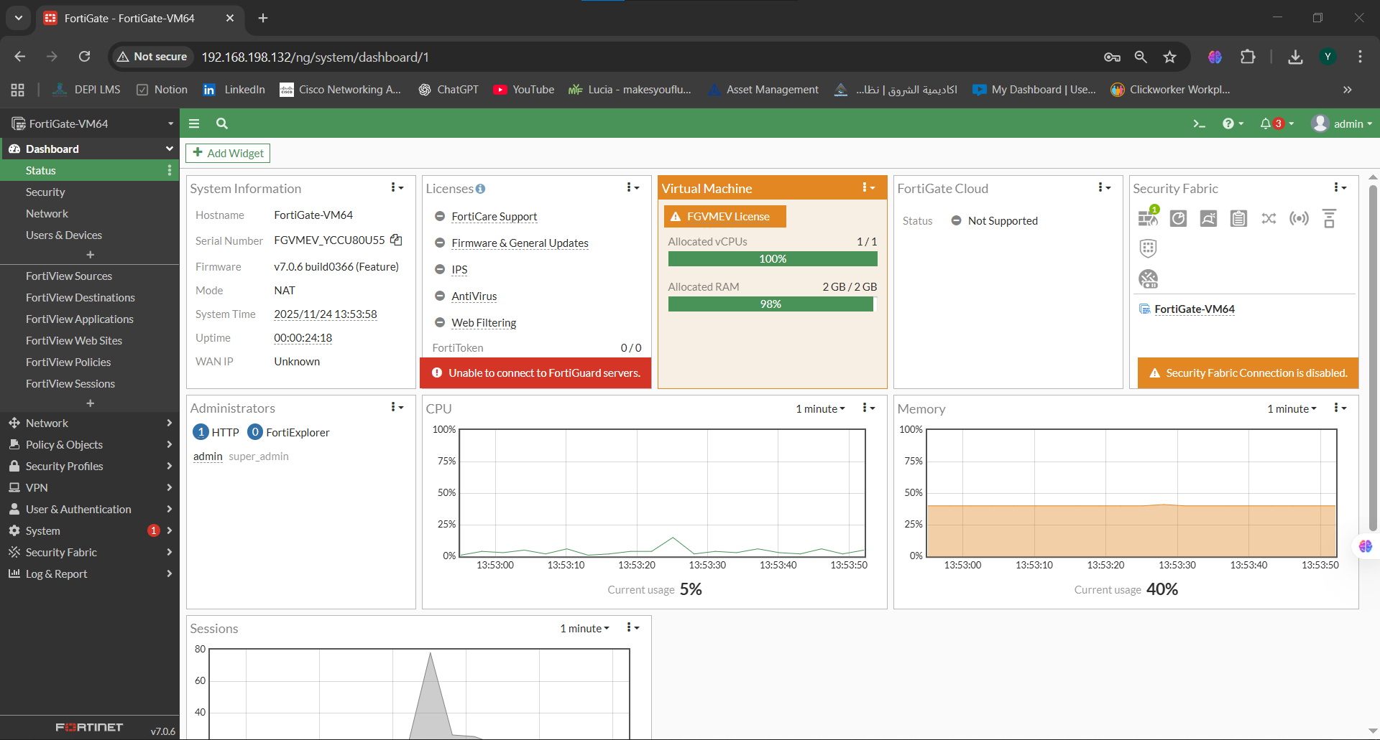

Figure 2 – Network Interfaces Overview

Displays all FortiGate interfaces including port1 (WAN) and port2 (LAN).
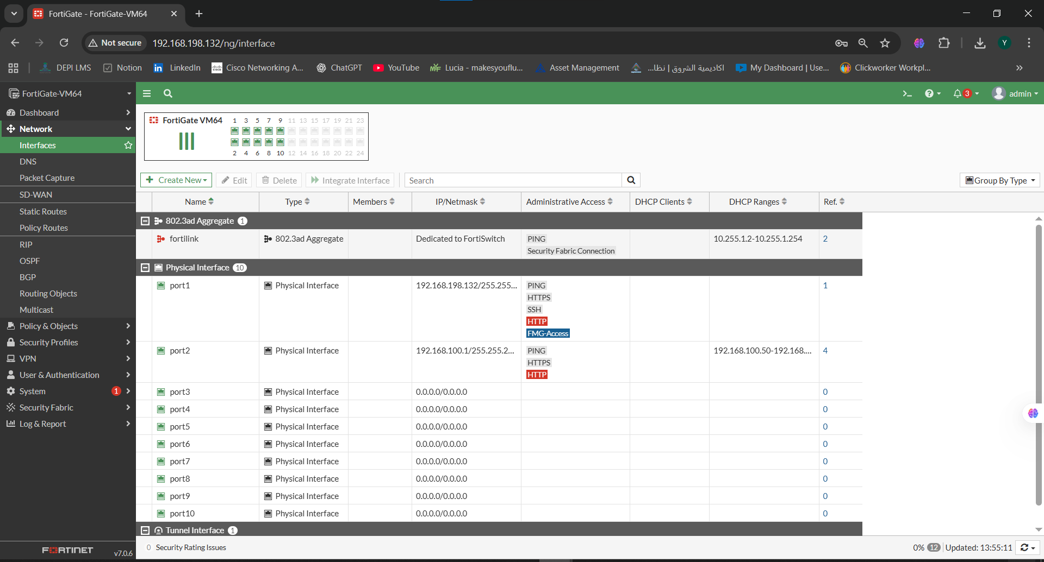

Figure 3 – Port1 (WAN) Configuration

port1 configured as the WAN interface using DHCP with assigned IP address.
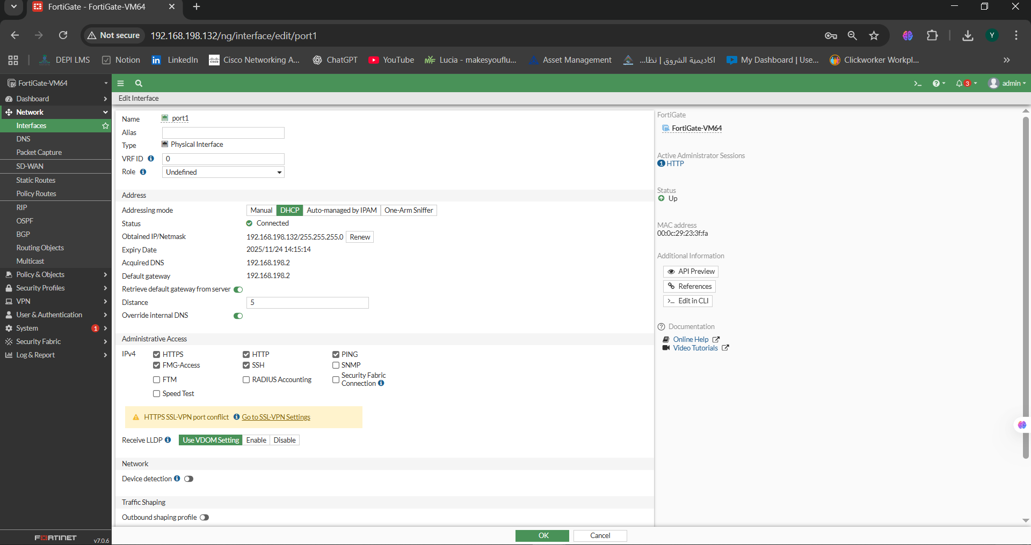

Figure 4 – Port2 (LAN) Configuration

port2 configured as the internal LAN interface with IP 192.168.100.1/24
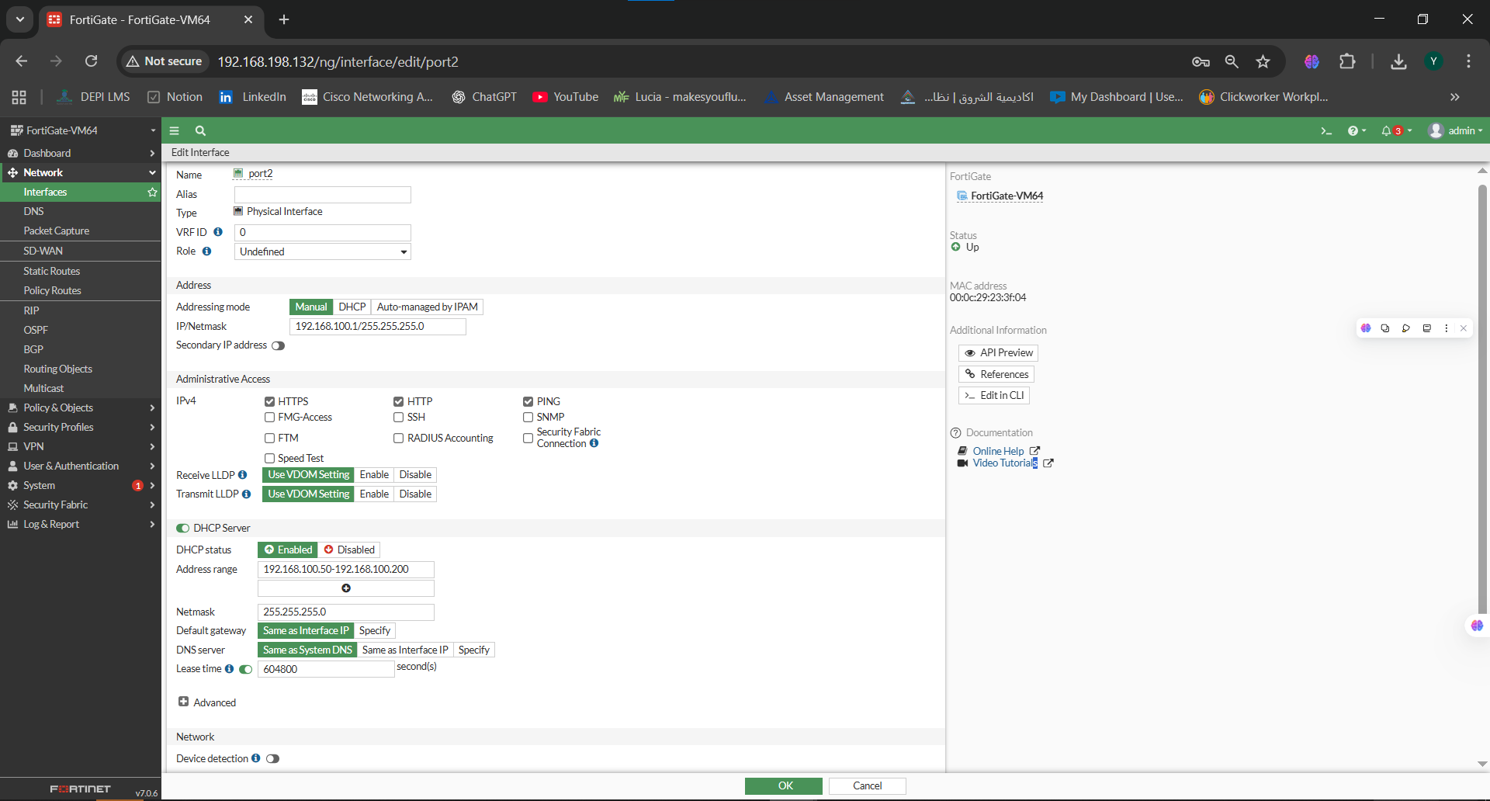

Figure 5 – Local User (yasmin_cli)

Shows creation of the local user used for SSL-VPN authentication
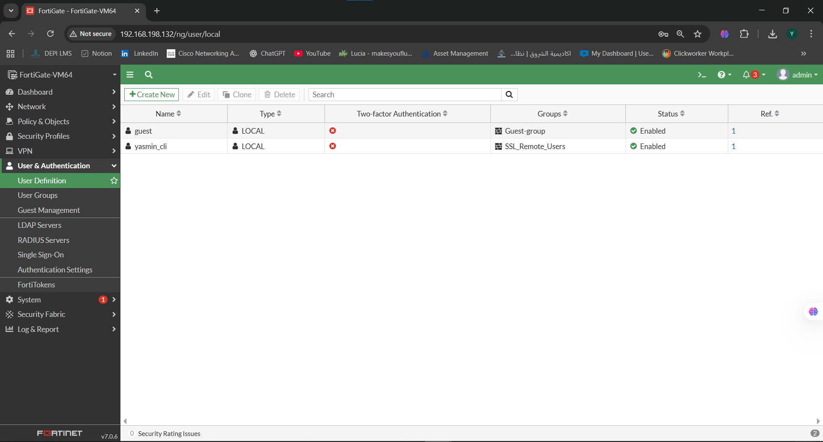

Figure 6 – Local User Details

Displays full configuration of the user yasmin_cli, including password and status
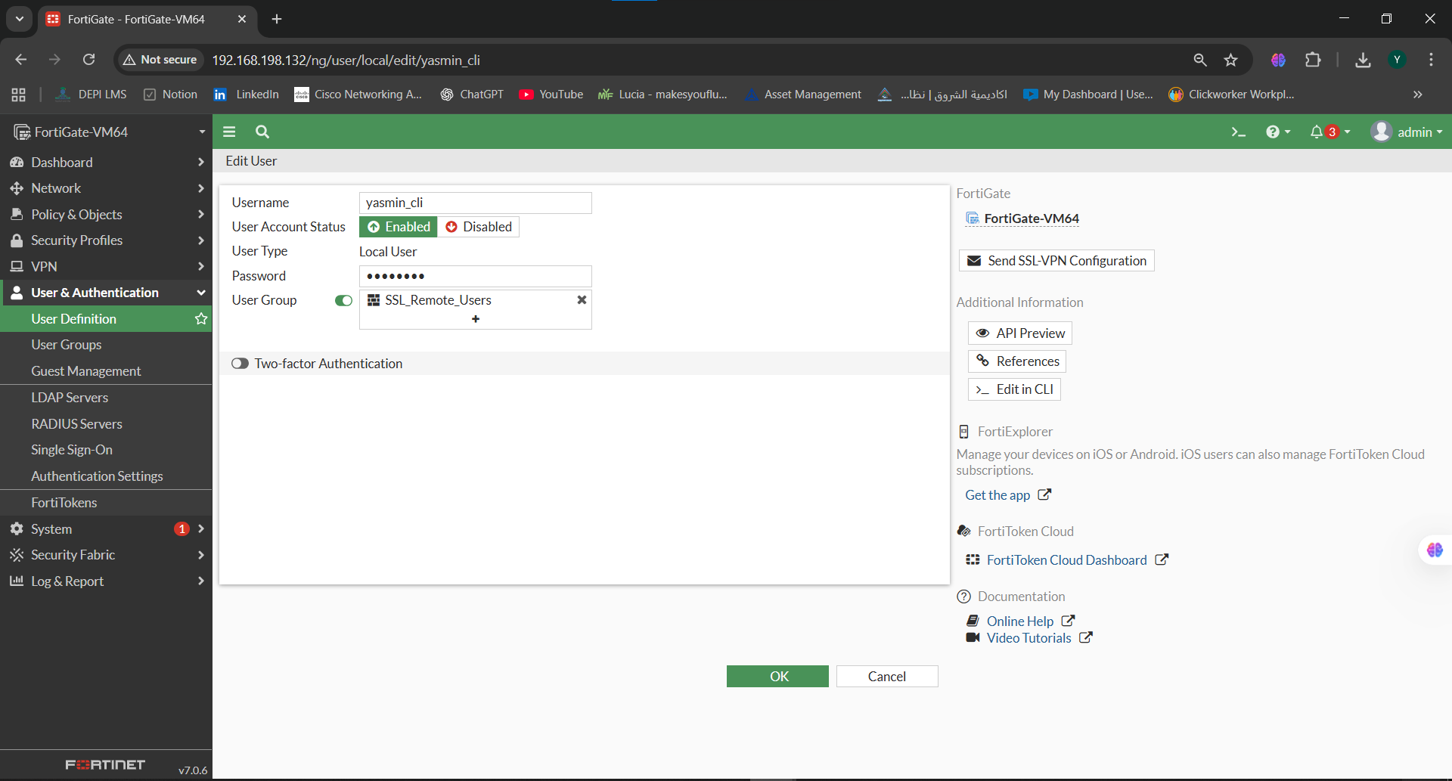

Figure 7 – SSL_Remote_Users Group

User group created to manage SSL-VPN remote access user
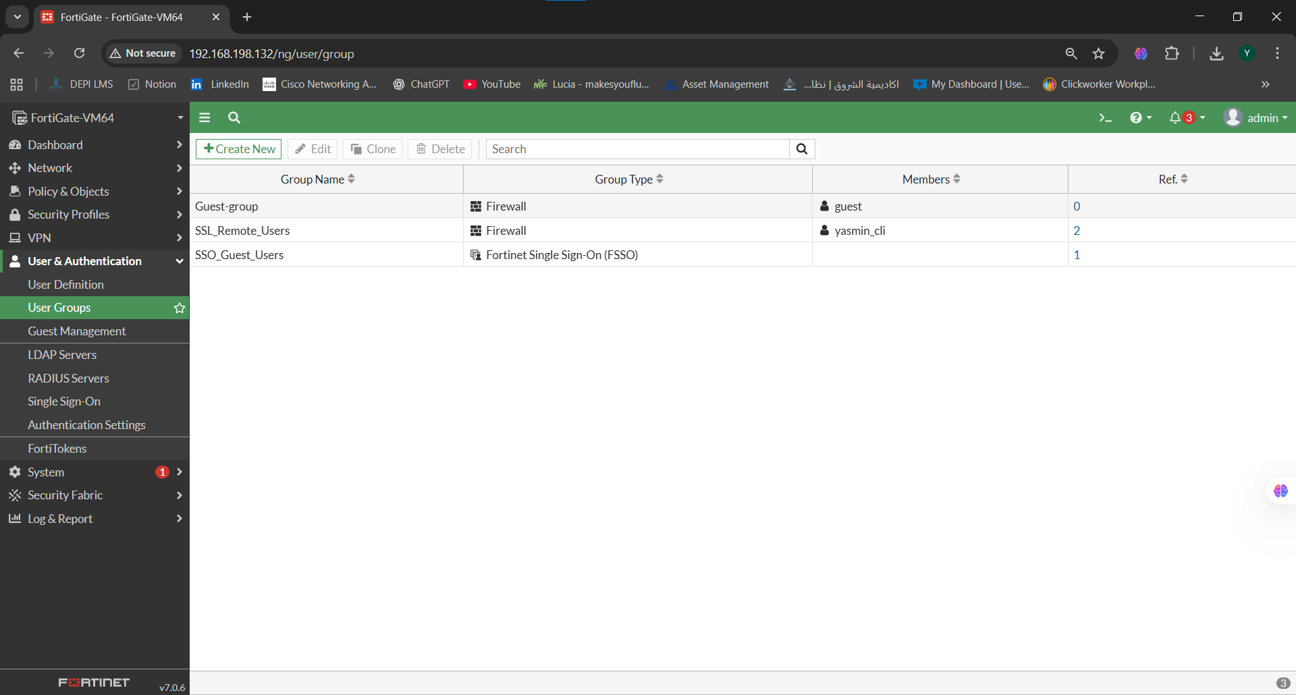

Figure 8 – Group Members

Shows the user yasmin_cli added to the SSL_Remote_Users grou
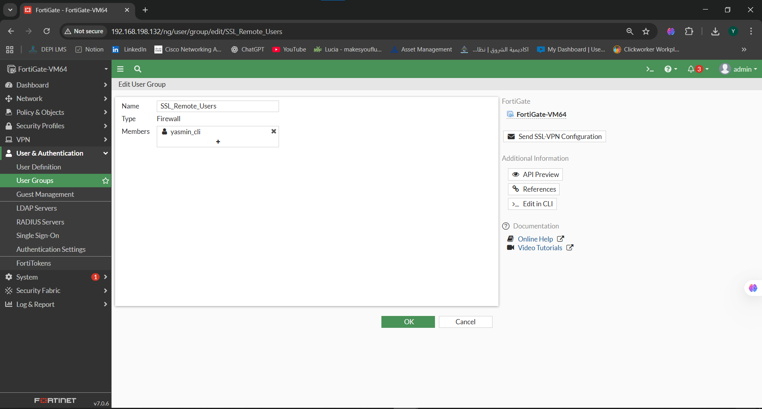

Figure 9 – SSL-VPN Settings (Main Page)

SSL-VPN enabled on port1 with tunnel mode and address pool configuration.
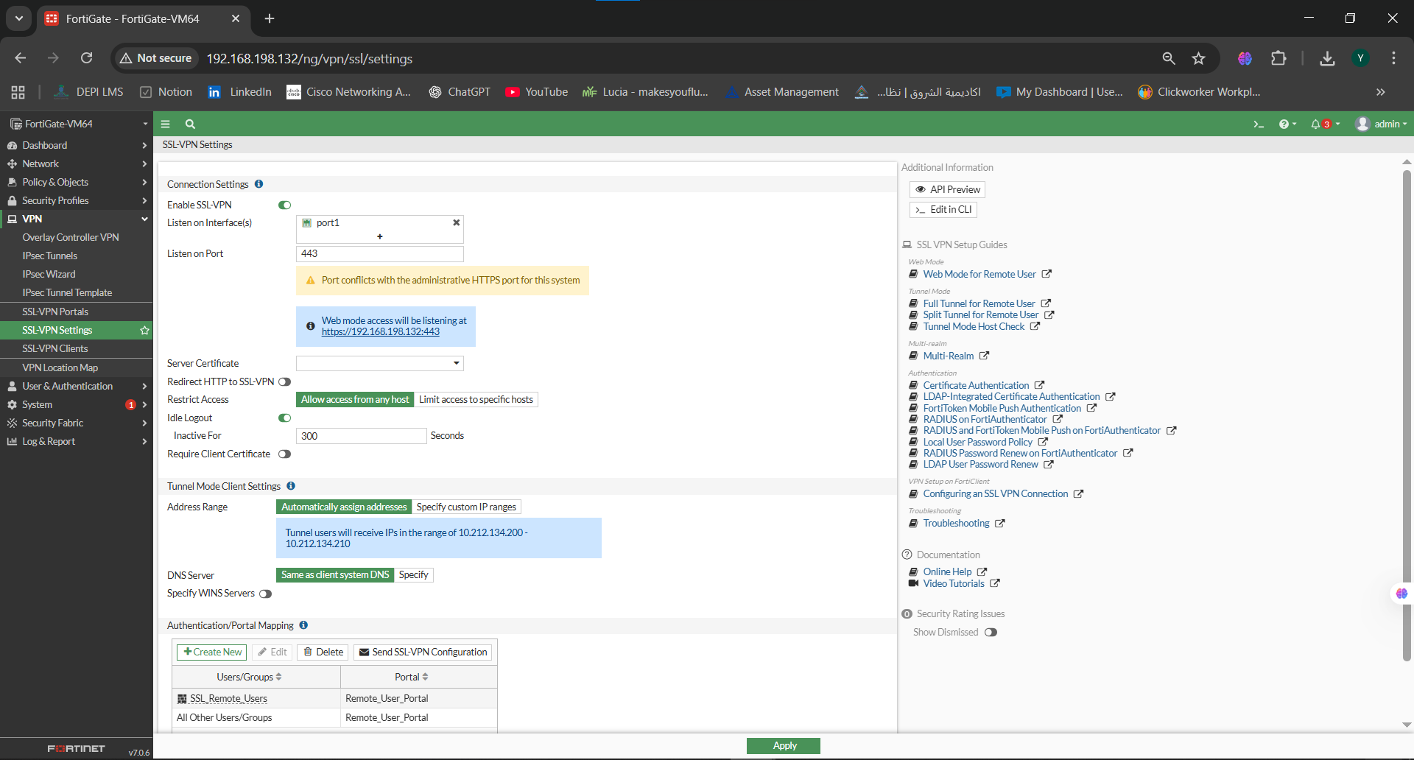

FIgure 10 – SSL-VPN Portal (Remote_User_Portal)

Portal settings for remote users including split tunneling and routing options.
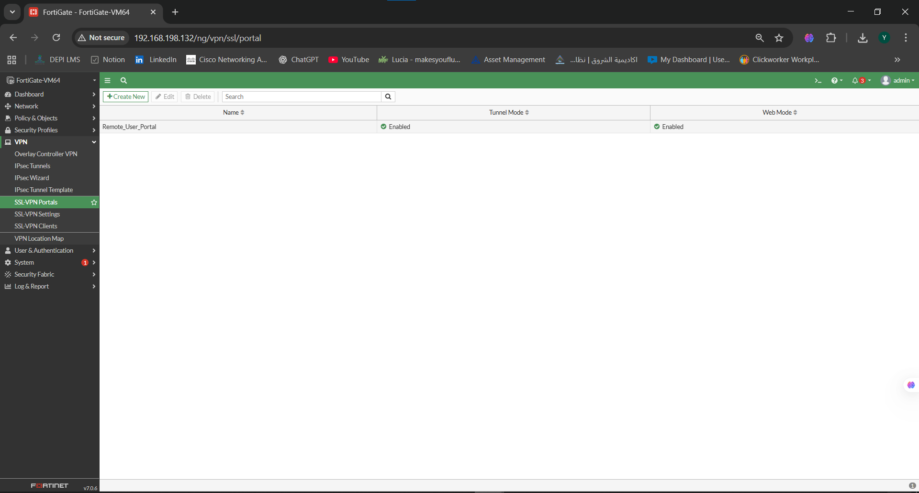

Figure 11 – SSL-VPN Portal Configuration (Remote_User_Portal) with Split-Tunneling Enabled and Routing Address Override Set to SSLVPN_TUNNEL_ADDR1

This configuration defines the SSL-VPN user portal settings, including tunnel mode behavior, split tunneling based on policy destination, and the IP pool assigned to remote users
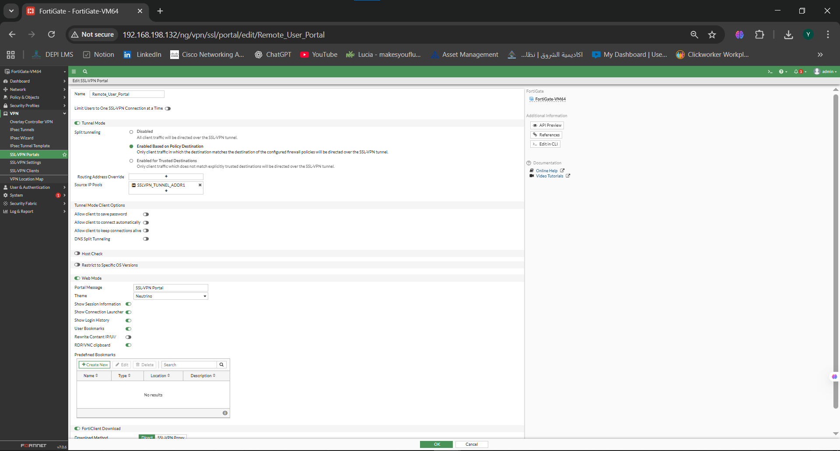

Figure 12 – Firewall Policies Overview Overview of the SSL-VPN firewall policies, including LAN_to_SSLVPN and SSLVPN_to_LAN rules.

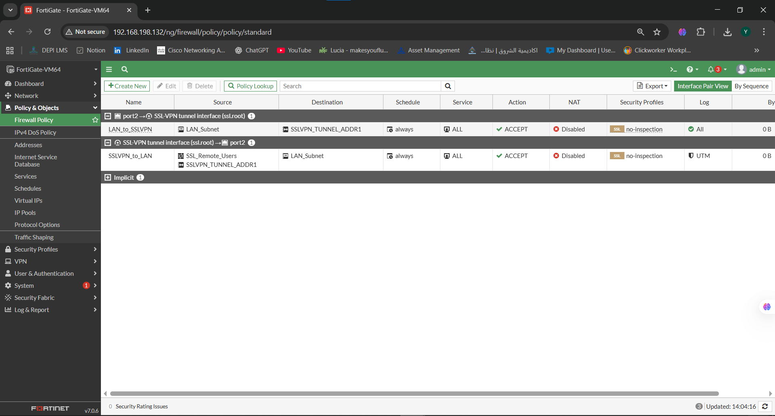

Figure 13 – Firewall Policy: LAN → SSLVPN

firewall Policy allowing LAN_Subnet to communicate with SSLVPN_TUNNEL_ADDR1 through port2 → ssl.root
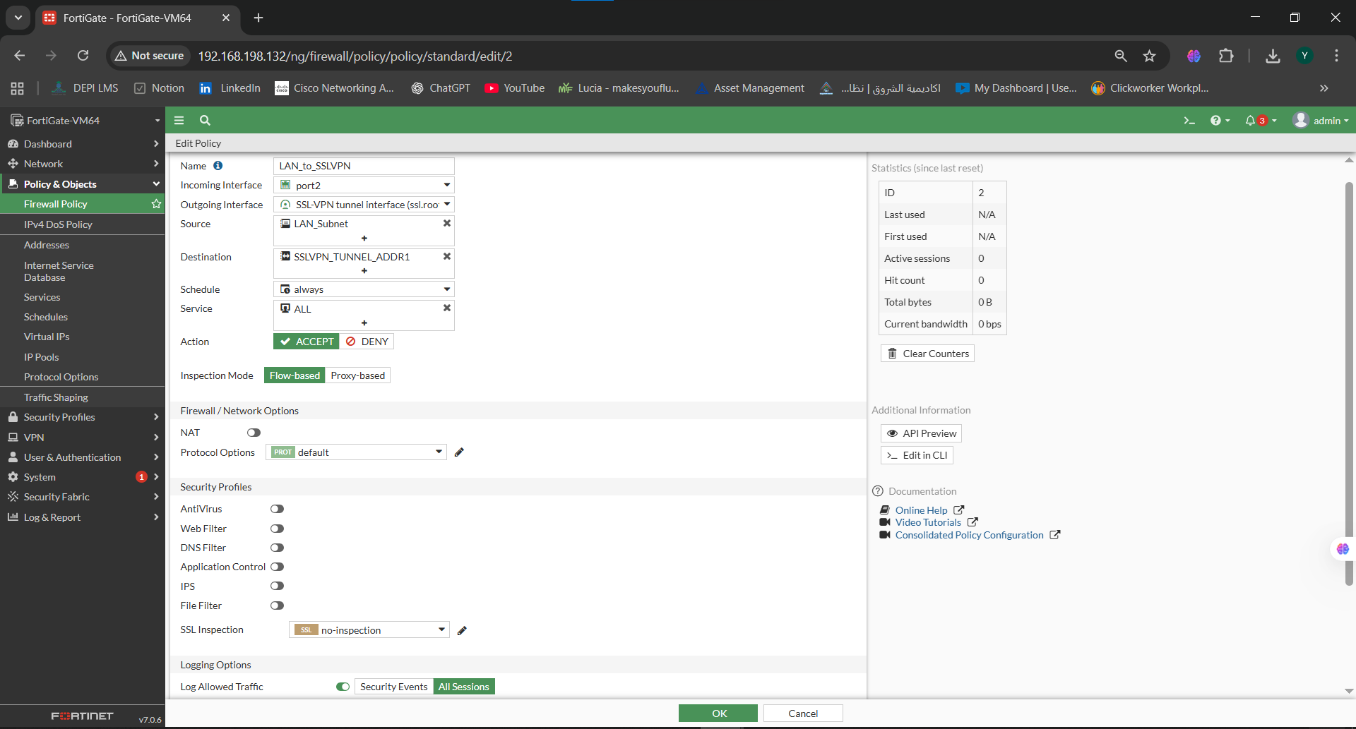
Figure 14 – Firewall Policy: SSLVPN → LAN
Policy allowing SSL-VPN users to access the LAN subnet
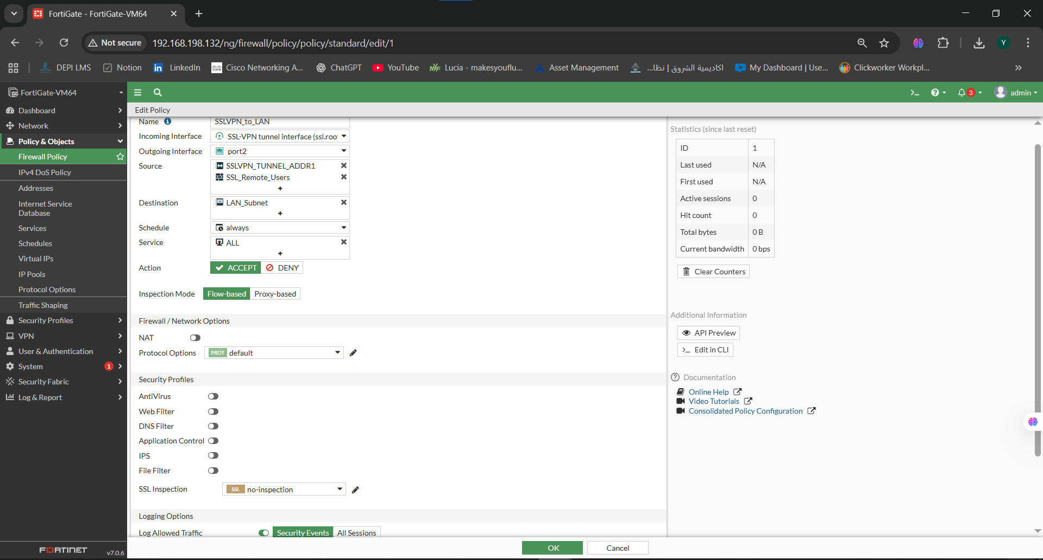

Test Results
Due to the limitations of the FortiGate VM (no SSL-VPN license),
VPN connection testing could not be performed in Week 1.
However, all required SSL-VPN configuration steps were completed successfully, including:
- Interface configuration
- Local user creation
- User group assignment
- SSL-VPN portal setup
- Tunnel IP range configuration
- Firewall policies for SSL-VPN traffic

Conclusion
All SSL-VPN configurations required for Week 1 have been successfully completed, including interfaces, users, groups, SSL-VPN settings, portals, and firewall policies. Connection testing is not required in this phase.

